**NEIGHBOURHOOD PLAN CHARMOUTH**

Want to see what the draft objectives and policies are looking like? Then come along to the presentation!!

**OPEN FORUM**

At the Community Hall in Lower Sea Lane **Saturday 5th January 2019**

Presentation at 10.30am

Followed by tea/coffee & cakes

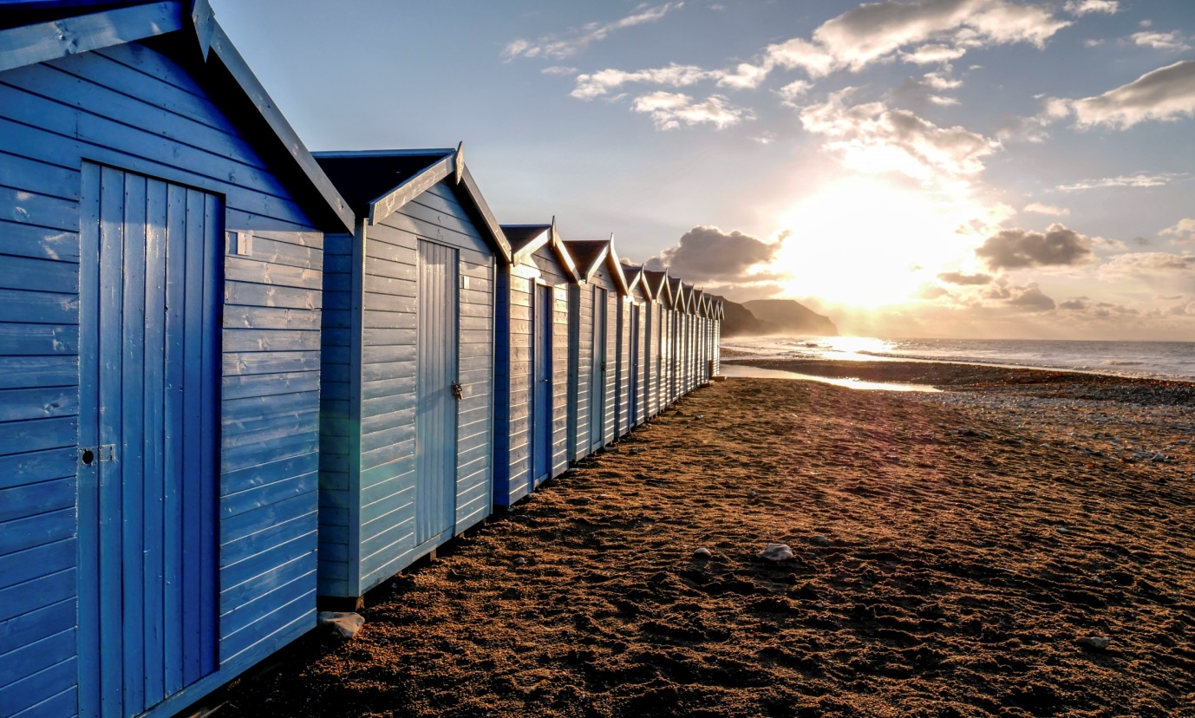

Look forward to seeing you !!